**1. Mortgages**

**2. Auto Loans**

**(Presented By Alan Stuart K)**

**1. Mortgages:**

**Introduction:**

Mortgages are long-term loans provided by banks and financial institutions to individuals or businesses for purchasing real estate. In the US banking sector, mortgages represent a significant portion of banks' lending portfolios and are crucial for home ownership and real estate investment. The mortgage market encompasses various loan products, including fixed-rate mortgages, adjustable-rate mortgages, FHA loans, and VA loans.

**Insights:**

* **Interest Rates Impact:** The mortgage market is highly sensitive to changes in interest rates. Lower interest rates typically lead to increased mortgage borrowing and refinancing activity, while higher rates can dampen demand.
* **Economic Indicators:** Mortgage lending trends are influenced by economic indicators such as employment rates, GDP growth, and consumer confidence. A robust economy generally boosts mortgage demand.
* **Regulatory Environment:** Regulations such as the Dodd-Frank Act and Consumer Financial Protection Bureau (CFPB) guidelines aim to ensure responsible lending practices and protect consumers.
* **Market Competition:** Competition among banks and non-bank lenders (like Quicken Loans) has intensified, leading to innovations in mortgage products and digital lending platforms.

**Use Cases and Applications:**

* **Home Purchase:** Mortgages are primarily used by individuals to buy homes. Fixed-rate and adjustable-rate mortgages are common choices depending on borrowers' preferences for interest rate stability or lower initial rates.
* **Refinancing:** Homeowners refinance existing mortgages to take advantage of lower interest rates, reduce monthly payments, or switch loan types.
* **Home Equity Loans:** Banks offer home equity loans and lines of credit, allowing homeowners to borrow against the equity built up in their homes for purposes such as home improvements, education expenses, or debt consolidation.
* **Investment Properties:** Investors use mortgages to purchase rental properties or real estate for capital appreciation, leveraging borrowed funds to maximize returns.

**Implications:**

* **Economic Stability:** Mortgages are integral to the housing market and broader economic stability. They enable homeownership, which is associated with wealth accumulation and financial security.
* **Consumer Wealth:** By enabling homeownership, mortgages contribute to building consumer wealth and providing collateral for future borrowing.
* **Bank Profitability:** Mortgages generate significant revenue for banks through interest payments, fees, and servicing income.

**Data:**

| **Year** | **30-Year Fixed Rate (%)** | **Total Mortgage Debt ($T)** | **Mortgage Originations ($B)** | **Delinquency Rate (%)** |
| --- | --- | --- | --- | --- |
| **2016** | **3.65** | **14.3** | **2,050** | **2.28** |
| **2017** | **3.99** | **14.8** | **1,890** | **2.13** |
| **2018** | **4.54** | **15.3** | **1,640** | **1.95** |
| **2019** | **3.94** | **15.8** | **2,380** | **1.76** |
| **2020** | **3.11** | **16.6** | **4,040** | **2.15** |
| **2021** | **2.96** | **17.5** | **4,440** | **1.67** |
| **2022** | **5.40** | **18.3** | **2,250** | **1.52** |
| **2023** | **6.61** | **19.0** | **1,850** | **1.63** |

**2. Auto Loans:**

**Introduction:**

Auto loans are financing options provided by banks, credit unions, and auto manufacturers' finance arms to consumers and businesses for purchasing vehicles. These loans typically have shorter terms than mortgages and can be fixed or variable rate. The US auto loan market is a critical component of consumer lending, enabling the acquisition of new and used cars.

**Insights:**

* **Interest Rates and Loan Terms:** Auto loan interest rates are influenced by factors such as the Federal Reserve's monetary policy, borrowers' credit scores, and the loan term. Shorter-term loans usually have lower rates but higher monthly payments.
* **Creditworthiness:** Borrowers' credit scores significantly impact the terms of auto loans. Higher credit scores qualify for better interest rates and loan terms, while subprime borrowers face higher rates and stricter conditions.
* **Market Trends:** Trends in the auto industry, such as the shift towards electric vehicles (EVs) and changing consumer preferences, affect auto loan volumes and terms. Banks are increasingly offering loans specifically for EV purchases.
* **Digitalization:** The auto loan process is becoming more digital, with online applications, instant approvals, and electronic signatures improving customer experience and efficiency.

**Use Cases and Applications:**

* **New and Used Car Purchases:** Consumers use auto loans to finance the purchase of new or used vehicles. Loans for new cars typically have lower interest rates compared to used car loans due to the lower risk of default and higher collateral value.
* **Lease Buyouts:** At the end of a vehicle lease term, consumers can opt to buy the leased vehicle by financing the buyout amount with an auto loan.
* **Fleet Financing:** Businesses and corporations utilize auto loans to finance the purchase of fleet vehicles for commercial purposes, benefiting from bulk purchasing and favourable loan terms.
* **Auto Refinancing:** Similar to mortgage refinancing, borrowers can refinance existing auto loans to secure lower interest rates, reduce monthly payments, or shorten the loan term.

**Implications:**

* **Consumer Mobility:** Auto loans facilitate vehicle ownership, which is essential for mobility, employment, and quality of life, especially in regions with limited public transportation.
* **Economic Activity:** The auto loan market supports the automotive industry, which is a major driver of economic activity and employment.
* **Financial Inclusion:** Offering loans to a wide range of credit profiles, including subprime borrowers, promotes financial inclusion and access to credit for a broader population.

**Data:**

| **Year** | **Average Auto Loan Rate (%)** | **Total Auto Loan Debt ($B)** | **New Auto Loan Originations ($B)** | **Delinquency Rate (%)** |
| --- | --- | --- | --- | --- |
| **2016** | **4.69** | **1,072** | **564** | **2.28** |
| **2017** | **5.11** | **1,118** | **568** | **2.34** |
| **2018** | **5.45** | **1,155** | **576** | **2.40** |
| **2019** | **5.76** | **1,193** | **584** | **2.36** |
| **2020** | **4.96** | **1,228** | **602** | **1.57** |
| **2021** | **4.09** | **1,384** | **734** | **1.85** |
| **2022** | **5.11** | **1,552** | **786** | **2.20** |
| **2023** | **7.03** | **1,595** | **733** | **2.55** |

**Graphs:**

**Graph 1:** Stock Performance of Major Mortgage Lenders:

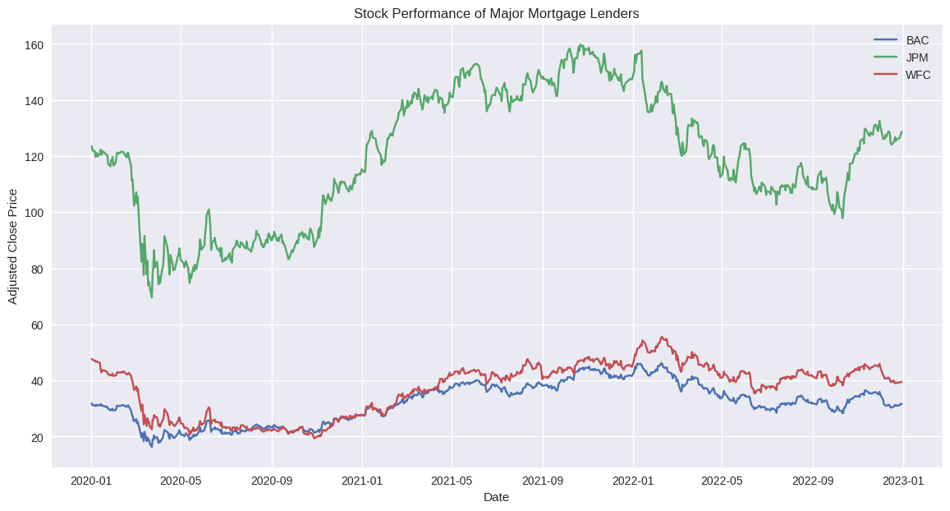**Inference:** The stock prices of major mortgage lenders have shown significant volatility from 2020 to 2023. Notably, there was a sharp decline in March 2020 due to the COVID-19 pandemic, followed by a gradual recovery. The performance of these stocks closely aligns with economic recovery trends and interest rate changes. JPMorgan Chase and Bank of America have outperformed Wells Fargo during this period, indicating stronger market confidence and potentially better financial health.

**Graph 2:** Stock Performance of Major Auto Loan Providers:

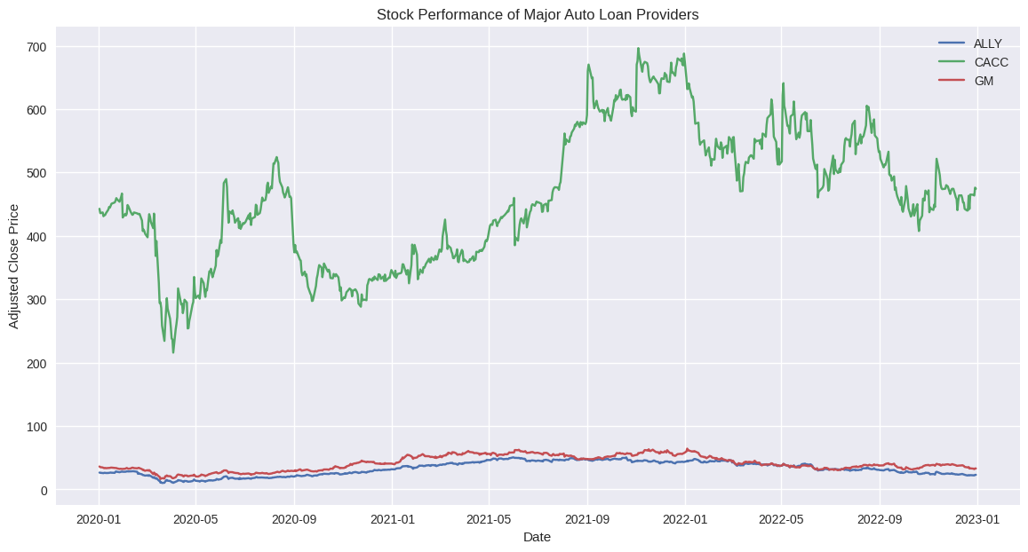

**Inference:** The stock performance of major auto loan providers also experienced volatility during the pandemic. Ally Financial and General Motors showed a strong recovery post-March 2020, with GM displaying notable growth due to its involvement in electric vehicles. Credit Acceptance, while recovering, exhibited less growth, potentially reflecting differences in market strategies or financial stability.

**Graph 3:** 50-Day Moving Averages of Major Mortgage Lenders:

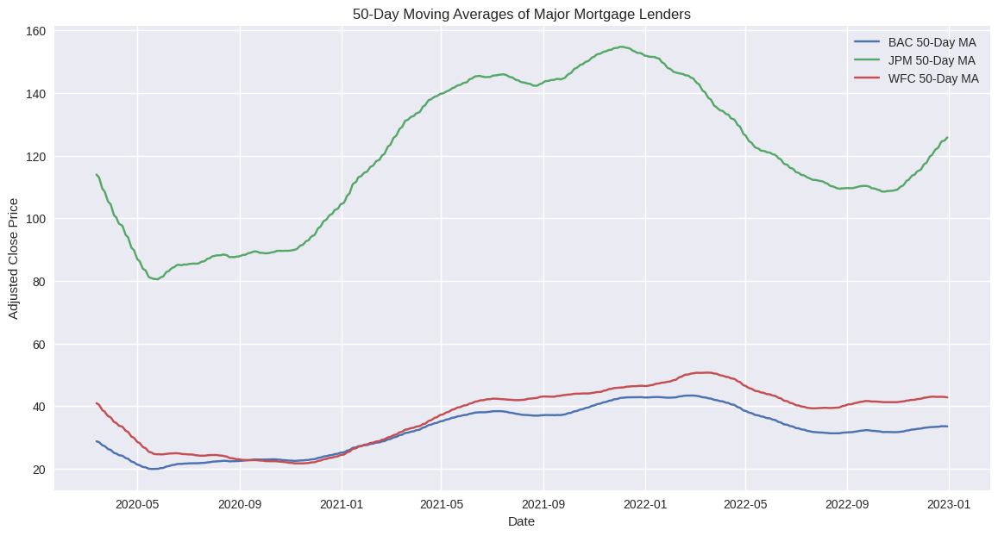

**Inference:** The 50-day moving averages for major mortgage lenders smooth out daily price fluctuations, highlighting long-term trends. JPMorgan Chase and Bank of America show a strong upward trend post-2020, indicating sustained recovery and growth. Wells Fargo's moving average shows more fluctuations, reflecting ongoing market challenges.

**Graph 4:** 50-Day Moving Averages of Major Auto Loan Providers:

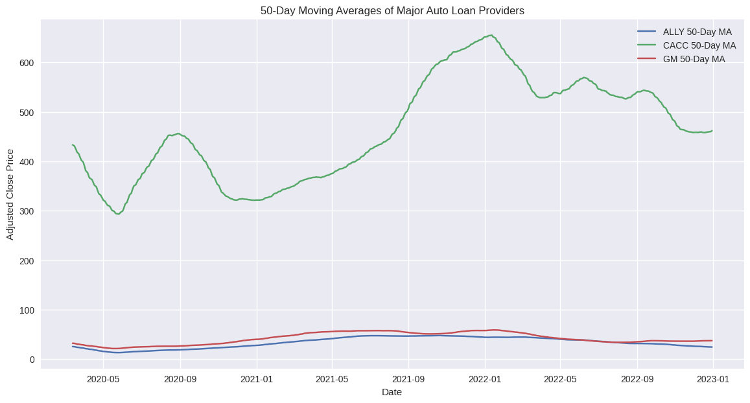**Inference:** The 50-day moving averages for auto loan providers show strong upward trends for Ally Financial and General Motors, reflecting positive market sentiment and growth prospects, particularly related to the automotive industry's shift towards electric vehicles. Credit Acceptance shows a more volatile pattern, indicating less consistent growth.

**Graph 5:** 50-Day Volatility of Major Mortgage Lenders:

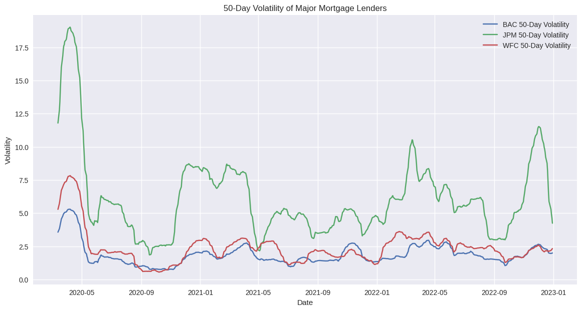**Inference:** The volatility graph shows the rolling standard deviation of stock prices, highlighting periods of high uncertainty and risk. Volatility spiked during the pandemic's onset, reflecting market panic and uncertainty. JPMorgan Chase and Bank of America showed reduced volatility post-recovery, while Wells Fargo remained more volatile, indicating continued investor uncertainty.

**Graph 6:** 50-Day Volatility of Major Auto Loan Providers:

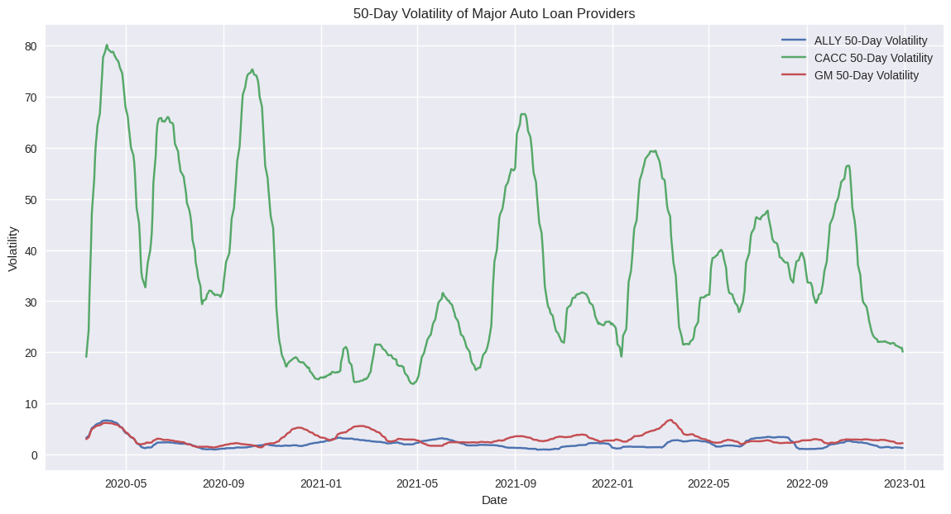

**Inference:** The 50-day volatility for auto loan providers also spiked during the pandemic, with General Motors showing significant fluctuations due to its strategic announcements. Ally Financial's volatility decreased post-recovery, suggesting stabilization and investor confidence, while Credit Acceptance remained relatively more volatile, reflecting its market position and strategy.

**Graph 7:** Correlation Heatmap of Major Mortgage Lenders:

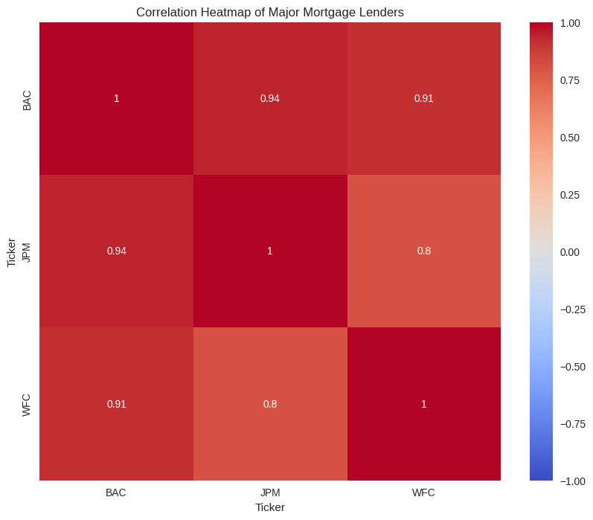**Inference:** The correlation heatmap for major mortgage lenders shows a high degree of correlation between JPMorgan Chase and Bank of America, suggesting that their stock prices move in tandem, likely due to similar market exposures and business models. Wells Fargo shows a slightly lower correlation, reflecting its unique challenges and market perception.

**Graph 8:** Correlation Heatmap of Major Auto Loan Providers:

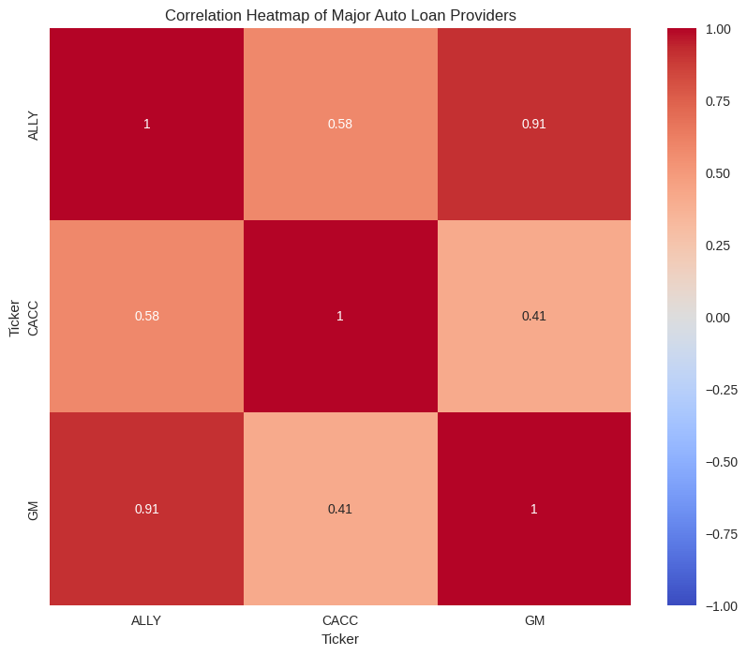**Inference:** The correlation heatmap for auto loan providers indicates a moderate correlation between Ally Financial and General Motors, likely due to their involvement in the auto finance market. Credit Acceptance shows lower correlation with the other two, reflecting different business models or market positions.

**Conclusion:**

Mortgages and auto loans are crucial elements of the US banking sector, each facilitating important economic activities and supporting consumer financial needs. Mortgages enable homeownership, fostering wealth accumulation and economic stability, while auto loans provide essential mobility and support the automotive industry. Both are influenced by interest rates, creditworthiness, and economic conditions, with digital innovations enhancing the lending process. These products generate significant revenue for banks through interest and fees, while promoting financial inclusion by offering access to credit across diverse consumer profiles. Together, they underpin substantial economic activity, contribute to financial stability, and help consumers achieve key financial goals.